**A STUDY ON CANNIBALIZATION OF SALES**

**IN SMARTPHONE INDUSTRY**

A Comprehensive Internship Report

***SUBMITTED TO***

**International Management Institute**

**Bhubaneswar**



**IN PARTIAL FULFILMENT FOR THE AWARD OF POST GRADUATE DIPLOMA**

IN

**MANAGEMENT**

By

**PATNALA SIVASREE**

**2019**

**ACKNOWLEDGMENT**

I would like to thank my project supervisor, **Prof. Niraj Vishwakarma**, International Management Institute, Bhubaneswar, who has always inspired and guided me in the true spirit of a teacher at every stage, spared his invaluable time, improved the rough draft of this project and provided the required guidance and support whenever approached. He consistently allowed this project report to be my own work, but also steered me in the right direction whenever he thought I required it.

I have a deep debt of gratitude towards **Prof. Ramakrushna Panigrahi**, International Management Institute, Bhubaneswar as the Supervisor after my guide Prof. Niraj Vishwakarma has left this project. I am gratefully indebted to him for his very valuable guidance and support on this project report.

**STUDENT’S UNDERTAKING**

I, **Patnala Sivasree** bearing Institute Roll No. **18PGDM-BHU050**, declare that the summer project titled “**A study on the cannibalization of sales in Smartphone industry”** is my original work and completed under the supervisions of **Prof. Niraj Vishwakarma and Prof. Ramakrushna Panigrahi** of IMI Bhubaneswar. Further, I also declare that the report being submitted herewith is free of any textual plagiarism.

Signature:

Date:

Place: **IMI Bhubaneswar**

**TABLE OF CONTENT**

1. **Executive Summary……………………………………………………….…….05**
2. **Introduction……………………………………………………………………….06**
3. **Industry Analysis…………………………………………………………………09**
4. **Research Methodology……………………………………...…………………..11**
5. **Literature Review.……..….………………………………………………………12**
6. **Research Factors...……………………………………………………………….13**
7. **Research Analysis..………………………………………………………………14**
8. **Comparison between two age groups……………………...…………………18**
9. **Conclusion……….…………………………………………………………………19**
10. **Bibliography……………..…………………………………………………………20**
11. **Questionnaire…………………………………………….………………………..21**

**Executive Summary**

Since the inception of the internet the smartphone manufactures are on the edge to keep up with the technology providing the customers with top notch specifications to get more and more customers. In doing so the companies have been so competitive that at a particular price point the companies started to produce different handsets and similar price with leads to confusion on the customer side this report is trying to evaluate the factors responsible for the cannibalization of sales between different sets

This report also tries to tell that if the factors are same for different age groups. The analysis done through the Conjoint analysis is and the part worth’s are calculated using the dummy variable regression. And the final importance of the following are factors and ranked and importance is calculated.

**Introduction**

The smartphone industry is racing in its own pace as the companies are trying to gain more and more market share. Now a days the smartphones are divided into 4 segments:

1. Budget
2. Mid-rangers
3. Premium
4. Flagships.

Budget and the mid rangers are most competitive as the most people have limited budget and the look for better options. The sales of the different smartphone brands in 2019 are as follows.

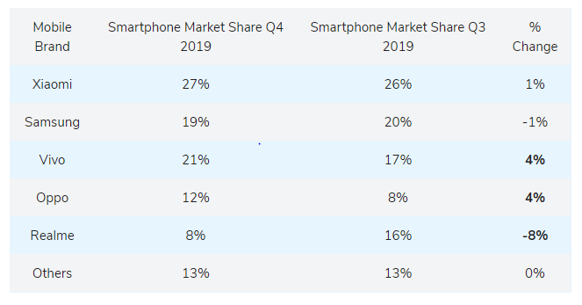

The headset released by each company is growing very high in number last year. Realme has released 27 hand sets in last 2 quarters that is almost 4 models for every month. So, the number of models is increasing with causes the newer models killing the sales of relatively new models with the handset expiring faster. Due to this the life time of a single smartphone are reducing very rapidly and the resources are being used up for this rush.

According to 2020 stats the average spending of smart phones is increasing to 15000 rupees. The latest technology of 5G will push the customers to increase the sales by shifting from the present 4G to 5G handsets.

While this is going in the budget and mid-rangers, premium and flagships are safe in this region as they are more expensive for the customers to change immediately the flagship ranges between 60000 to 1.5 lakh so these handsets are the crown jewel of the company mostly coming once in year from the company. So, this market is very safe and will be having no effect from these changes so in this research the smartphones which are flagships are not considered.

When we consider the top Smartphone maker in the world the number of models launched in the year 2019 are as follows:

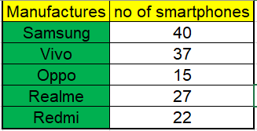

141 different models were released by the top manufacturers in the world which makes the market confused and unstable.

**Industry Analysis:**

The smartphone industry is one of the most fast-growing industry in the world with day by day new technology pouring its innovation in making the human life more automated and easier. The Industry analysis is done using PESTEL analysis and porters 5 forces.

**PESTEL ANALYSIS**

**P: Political:**

* The Government is laying huge restriction for several tech- companies and tech support companies which are not under the regulations. For e.g.: Huawei has been banned by the US governments as the relations between USA and China were not great.
* Government policies like Made In India, has give route to many companies to start their operations in India like Xiaomi in AP, Moto in Chennai TN etc...
* The support companies like Facebook and WhatsApp are being restricted with the data security policies.

**E: Economic:**

* The condition of global business has the impact on the sales, as we know that the average spending of the customer is increasing to 15000 rupees on smartphone the newer conditions being the wind for fire for the smartphone manufactures to get in to more sales also.
* The new trend of Smartphone being statues symbol also making people to change the smartphones regularly.

**S: Social:**

* The social connectivity is now a days is more dependent on the smartphones by being connected through various applications and easy to access.
* The smartphone manufactures are also coming up with new strategies to manufacture the smartphones for different social classes.
* The smartphones also make new smartphone communities like One plus community by One plus, Mi community by Xiaomi and Redmi.

**T: Technological:**

* Smartphone industry is one of the most evolving industry in terms of technology and will be taking the tech savvy people to be there main focused area.
* All the technological expansions make the smartphone industry to be vulnerable in making the changes and taking decisions. For e.g.: Nokia choose Microsoft over the Android which lead to fall of the company from being market leader to bottom of the table.
* Technological advancements also provide the more security to customers and users.

**E: Environmental:**

* The manufactures are facing challenging the challenging in reducing the SAR value from their products as part of environmental protection.
* Several companies also encourage the CSR activities in their own way e.g.: Xioami has opened there manufacturing plant in AP and they started giving working employment for the locals and being 95% of women has also gave the companies initiative of women empowerment in that regions.
* The dumping of e-waste is regulated by the government as the hazardous waste and the recycling of the mobile devices are being encourage by the companies.

**L: Legal:**

* The smartphone industry is one which is most prone to duplicity as the IPRs are difficult for the smartphones.
* Patents are available to these techs but are only utility patents. e.g.: apple sued Samsung for replicating their design but could only retrieve the half the amount they claimed because they have functional patent only.

**Porters 5 forces**

Porter 5 force model tells us the internal factors of the industry. The 5 forces of the porters model are:

1. Power of buyers
2. Power of Suppliers
3. Threat of new entrants.
4. Threat of substitutes
5. Industry Rivalry

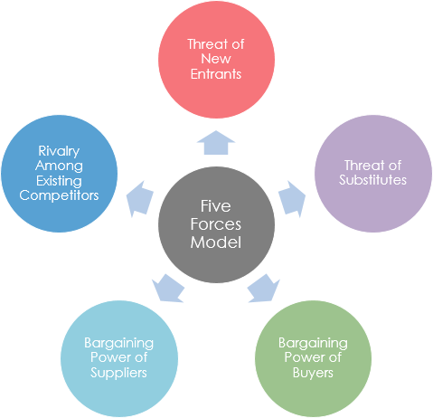

The various forces are explained below:

**Bargaining power of buyers:**

Bargaining power of buyers is high because as the number of manufacturers are very high so the shifting between the brands is very high so customers command most of the power here.

**Bargaining power of suppliers**

As, the number of manufacturers is are increasing the numbers of suppliers are also increasing the switching between for few resources are easy some are quite difficult such as displays made my Samsung and processors from Qualcomm etc... so, the bargaining power of Suppliers is moderate to high.

**Threat of New Entrants**

The entry barriers are quite high in Smartphone industry because most of the brands are sub-brands of well-established brands such as Redmi sub brand of Xioami, IQOO by Vivo, Realme by Oppo, thus creating very competitive environment for new entrants. So the threat of new entrants is low in this industry.

**Threat of substitutes:**

Threat of substitutes is very low because the real substitutes are Wearables which are exactly in the evolution stage, they did not get to peak of their product line so, the threat of substitutes are exactly low.

**Industry Rivalry**

Industry rivalry is very very high because of the switching power of customers. To make most of this the manufactures come up with almost new model as fast as possible making product line up very confusing and aggressive to be exact so the industry rivalry is very high.

**Research Methodology**

**Research problem:**

* What the important factors which contribute to the cannibalization of sales.
* Are these factors similar in case of age groups below and above 30?

**Research method:**

* The research is a primary research and the responses are taken by the questionnaire to people who have good knowledge of the smartphones and their specifications.
* In this research I tried to find the response at a particular price point and we assumed the price to be same for all the customers.
* We did not include the brand because all the options given are made by one company only.

**Research tool used**:

* I have used the Conjoint analysis to find out the relative part worth of each factors we chose.
* Also used dummy variable regression to find the part worth equations.

**Sampling Method**

* The sample taken is non probabilistic random sample.
* Sample consist of 60 people in which 55% are below 30 age and 45% are above 30 age group.

**Literature Review**

**Conjoint analysis:**

* Conjoint analysis is a statistical method which is used to find out how the individuals value the different features or the specifications of an individual product at different levels of each feature.
* It is the most effective way in market research for a company to find out the opinion of the customers and come up with the new product from a product mix.
* Conjoint analysis techniques may also be referred to as multi attribute compositional modelling, discrete choice modelling, or stated preference research.

The conjoint analysis is of 3 types:

* Ranking based conjoint.
* Rating based conjoint.
* Choice based conjoint.

In this report I have chosen the rating based conjoint against which each combination of specifications is rate according to the respondent preference.

**Dummy Variable Regression:**

Dummy variable regression is a technique which uses the 0 and 1 to know that is there any effect of the categorical variables on the preference of the respondents.

Then the coefficients are used to calculate the part worth equations and finally the importance.

The factors for the above analysis were taken by going through different research papers as below:

* The Potential for Cannibalization of New Products Sales by Remanufactured Products by V. Daniel R. Guide, Jr. Jiayi Li
* Organizing for Radical Product Innovation: The Overlooked Role of Willingness to Cannibalize Organizing for Radical Product Innovation Rajesh K. Chandy, Gerard J. Tellis
* Incorporating cannibalization models into demand forecasting 99 total citations on Dimensions Srinivasan, Sundara Ragharan; Ramakrishnan, Sreeram; Grasman, Scott E

**Factors**

The factors we have taken are:

Processor: the system on chip used by the manufactures mostly called the heart of the smartphone.

* The levels I chose for this is:

1. Qualcomm
2. MediaTek
3. Kirin.

Display: the type of Display panel used:

1. LCD
2. AMOLED.

Built: the footprint used by the manufacturer which in turn depicts the durability and the feel in hand.

1. Plastic.
2. Glass.

Centric: on which the mobile is focused on this type is majorly of 2 types

1. Camera centric (more focused on camera than others)
2. Performance centric (more focused on running smoothly)

Software: which type of software is manufacturer providing out of the box.

1. Stock (Google’s own UI or original Android)
2. Custom UI (manufacturers own custom Skin).

**Analysis**

Since the combinations were 48 combinations to make the questionnaire look simple, I ran Fractional Factorial Design (FFD) which gave me 8 combinations to cover all the alternatives.

Then conducted the dummy variable regression for the below 30 age group:

Results as below:

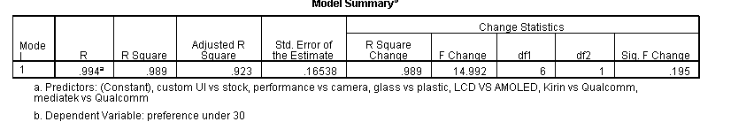

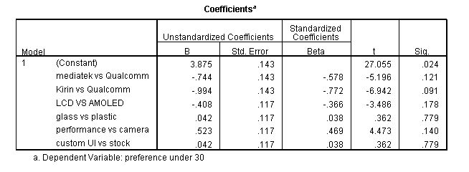

The coefficients are used for making the dummy variable equations:

**Processor:**

X12 – X11 = -0.744.

X13 – X11 = -0.994.

X11 + X12 + X13 = 0.

**Display:**

X12 – X11 = -0.408

X11 + X12 = 0.

**Built:**

X12 – X11 = 0.042

X11 + X12 = 0.

**Centric:**

X12 – X11 = 0.523

X11 + X12 = 0.

**Software:**

X12 – X11 = 0.042

X11 + X12 = 0.

After solving the above equations I got its as:

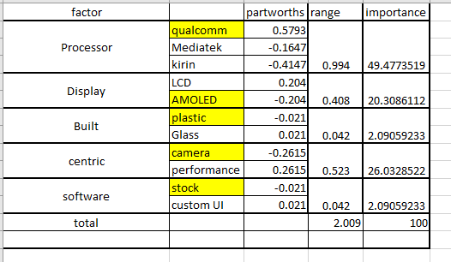

**Observations for below 30 age group:**

* From the above table after solving we find that the range of the processor is highest with 49.47 % importance.
* The second place is which centric device it is with 26.032% of importance.
* And display with 20.30% importance.
* The Qualcomm processor are more preferred by the customers so the handsets with Qualcomm processors are more prone to get sold than the others.
* The more devices towards the performance are more towards the getting sold.
* We can say that performance centric devices are more sold over the camera centric devices.

**Analysis for age group above 30:**

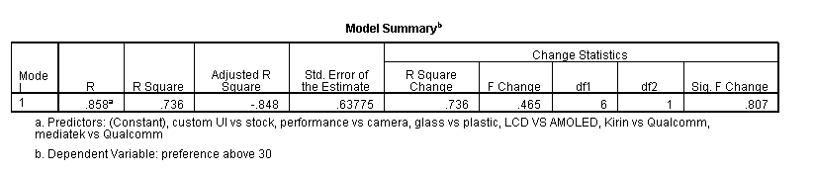The Dummy regression results for the age group above 30:

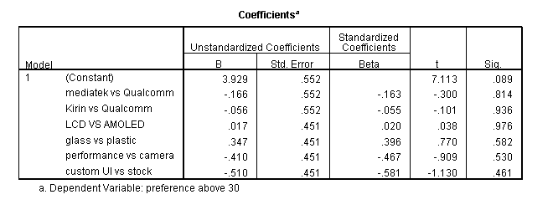

The dummy variable equations are

The coefficients are used for making the dummy variable equations:

**Processor:**

X12 – X11 = -0.166.

X13 – X11 = -0.056.

X11 + X12 + X13 = 0.

**Display:**

X12 – X11 = -0.17

X11 + X12 = 0.

**Built:**

X12 – X11 = 0.347

X11 + X12 = 0.

**Centric:**

X12 – X11 = -0.410

X11 + X12 = 0.

**Software:**

X12 – X11 = - 0.510

X11 + X12 = 0.

After solving the above equations, I got its as:

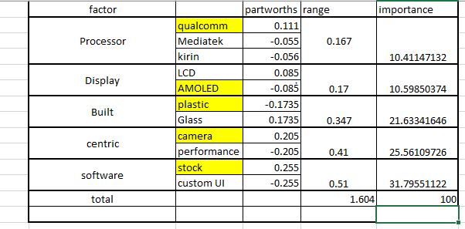

**Observations for above 30 age group:**

* From the above table after solving we find that the range of the Software is highest with 31.79 % importance.
* The second place is which centric device it is with 25.56% of importance.
* And built of the device with 21.6334% importance.
* The Stock Software are more preferred by the customers so the handsets with Stock software are more prone to get sold than the others.
* The more devices towards the Camera are more towards the getting sold.
* We can say that camera centric devices are more sold over the performance centric devices.

**Comparison between 2 age groups**

When we see the below 30 age group and above 30 age group we can see that the importance are very different to each other.

Ranking of importance in case of

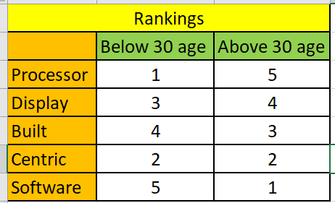

From the rankings we can see that rankings differ a lot between 2 groups. Most of the younger generation need good processor, a performance centric and good displays with very little opinion on the built and software.

While the older generation need clean software, good camera centric and strong built.

**Conclusion**

From the analysis I would recommend the manufacturers rather than producing a greater number of hand sets and killing their own products I would recommend to produce different devices for different age groups and do not release the products in rush.

**Recommendations:**

* The companies should launch 2 handsets in at least 2-3 months so that the sales can happen and the product can reach the saturation.
* The handset should focus on different age groups as the importance for the factors change for different age groups.
* Companies should aim to prolong the product life cycle as it makes the market saturated with frequent changes.

**BIBILOGRAPHY**

* The Potential for Cannibalization of New Products Sales by Remanufactured Products by V. Daniel R. Guide, Jr. Jiayi Li
* Organizing for Radical Product Innovation: The Overlooked Role of Willingness to Cannibalize Organizing for Radical Product Innovation Rajesh K. Chandy, Gerard J. Tellis
* Incorporating cannibalization models into demand forecasting 99 total citations on Dimensions Srinivasan, Sundara Ragharan; Ramakrishnan, Sreeram; Grasman, Scott E
* <https://www.youtube.com/watch?v=eQ3OV_an7Qo&t=81s>
* Identifying the effects of cannibalization on the product portfolio Sundara Raghavan Srinivasan, Sreeram Ramakrishnan, Scott E. Grasman

**Questionnaire**

A market research on factors responsible for the cannibalization of sales in smartphone market.

As the competition increasing in the smartphone industry i wanted to find out which are the major factors responsible for the cannibalization of sales in the market. In doing so i considered the following factors and the different levels under them with the assumption being the devices with following specifications are similarly priced.  
factors  
1. Processor (Qualcomm, MediaTek, Kirin)  
2. Display (LCD, AMOLED)  
3. Built (Plastic, Glass)  
4. Type (camera centric, performance centric)  
5. Software (stock, Custom UI)  
  
Sock software - the original android software without bloatware  
custom UI - software built on top of android software with provides customization.  
  
i did not considered apple because of the premium price tag to their phones.

* Required

Your Name? *



Your answer

Age *



Your answer

Rate your preference between 1- 5 of the different specification of the smartphone. *

Qualcomm, AMOLED display, plastic built, camera centric, custom UI

Qualcomm, LCD display, Glass built, performance centric, Stock

Kirin, AMOLED, Glass built, camera centric, Stock

Qualcomm, AMOLED, Glass built, performance centric, Custom UI

Qualcomm, LCD display, plastic built, camera centric, Stock

Kirin, LCD display, plastic built, performance centric, Custom UI

MediaTek, AMOLED display, plastic built, performance centric, Stock

MediaTek, LCD display, Glass built, camera centric, Custom UI